**Oracle Stored Procedures**

1. **Booking details of the customer**

create or replace PROCEDURE GENRECOUNT (INPUT_GENREID INTEGER)

AS

MOVIECOUNT INT;

BEGIN

SELECT count(M.MOVIEID) MovieCount INTO MOVIECOUNT

FROM MOVIES M

INNER JOIN MOVIE_GENRES MG

ON M.MOVIEID=MG.MOVIEID

INNER JOIN GENRE G

ON MG.GENREID=G.GENREID

where G.GENREID=INPUT_GENREID

group by G.Type;

IF(MOVIECOUNT>0) THEN

DBMS_OUTPUT.PUT_LINE ('' || MOVIECOUNT);

ELSE

DBMS_OUTPUT.PUT_LINE ('NO MOVIES FOR THIS');

END IF;

END;

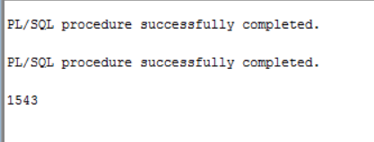

**--2 To show details of tickets sold for a particular showtime**

create or replace PROCEDURE ShowtimeDetails (INPUT_showtimeid INTEGER)

AS

ticketSold INT;

showtime varchar(50);

BEGIN

select count(Bookings.BookingID) TotalTicketsSold,Showtime.StartTime Showtimes INTO ticketSold,showtime

from movies

inner join showtime

on movies.MovieID=Showtime.MovieID

inner join Ticket

on Showtime.ShowtimeID=ticket.ShowtimeID

inner join Bookings

on ticket.TicketID=bookings.TicketID

where showtime.SHOWTIMEID=INPUT_showtimeid

group by showtime.StartTime;

IF(ticketSold>0) THEN

DBMS_OUTPUT.PUT_LINE ('Ticket_Sold: ' || ticketSold);

DBMS_OUTPUT.PUT_LINE ('Start_Time: ' || showtime);

ELSE

DBMS_OUTPUT.PUT_LINE ('Invalid showtimeID');

END IF;

END;

SET SERVEROUTPUT ON

EXECUTE ShowtimeDetails(4);

